Pallavi Pratheesh
23MIS0679
Automating build process using Maven
maven commands:
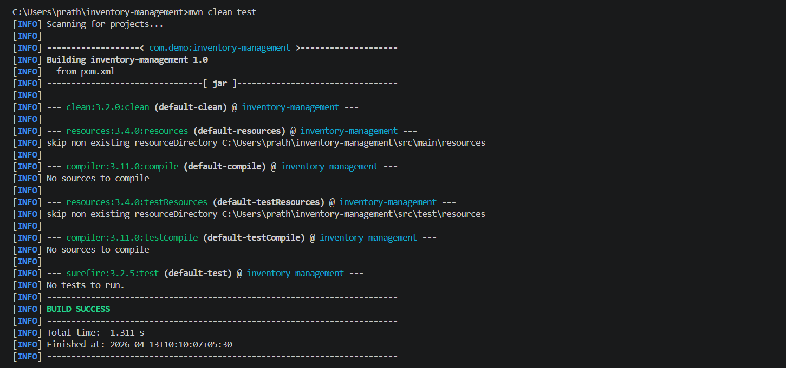
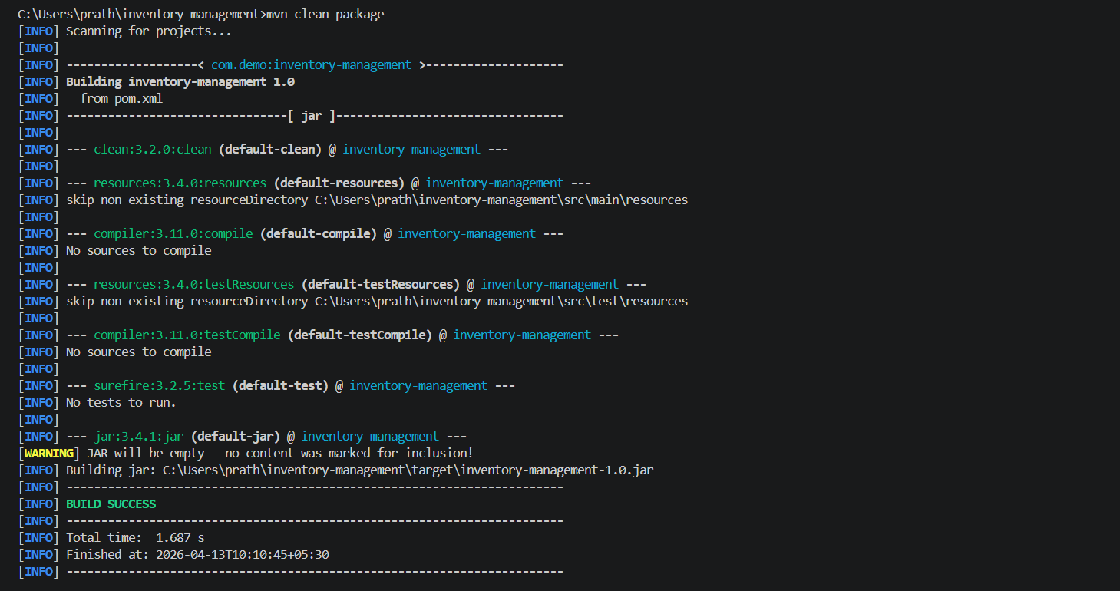
Folder structure for Inventory-Management System

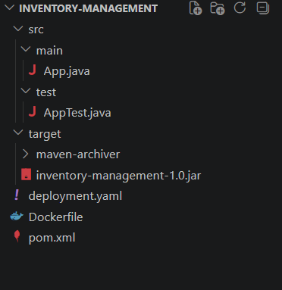
CODES
App.java
import java.util.*;

public class App {

private Map<String, Integer> data = new HashMap<>();

// ADD PRODUCT (CREATE)
public void create(String product, int quantity) {
if (product == null || product.trim().isEmpty()) {
throw new IllegalArgumentException("Product cannot be empty");
}
data.put(product, quantity);
}

// GET STOCK (READ)
public int get(String product) {
return data.getOrDefault(product, 0);
}

// UPDATE STOCK
public boolean update(String product, int change) {
if (data.containsKey(product)) {
int newStock = data.get(product) + change;

if (newStock < 0) {
return false; // not enough stock
}

data.put(product, newStock);
return true;
}
return false;
}

// DELETE PRODUCT
public boolean delete(String product) {
return data.remove(product) != null;
}

public static void main(String[] args) {
System.out.println("Inventory App Running...");
}
}
AppTest.java
import static org.junit.jupiter.api.Assertions.*;
import org.junit.jupiter.api.BeforeEach;
import org.junit.jupiter.api.Test;

public class AppTest {

private App app;

@BeforeEach
void setUp() {
app = new App();
}

// TEST CREATE + GET
@Test
void testCreateAndGet() {
app.create("Item1", 10);
assertEquals(10, app.get("Item1"));
}

// TEST STOCK INCREASE
@Test
void testIncreaseStock() {
app.create("Item2", 5);
boolean updated = app.update("Item2", 5);

assertTrue(updated);
assertEquals(10, app.get("Item2"));
}

// TEST STOCK DECREASE SUCCESS
@Test
void testDecreaseStockSuccess() {
app.create("Item3", 10);
boolean updated = app.update("Item3", -4);

assertTrue(updated);
assertEquals(6, app.get("Item3"));
}

// TEST STOCK DECREASE FAILURE
@Test
void testDecreaseStockFailure() {
app.create("Item4", 3);
boolean updated = app.update("Item4", -5);

assertFalse(updated);
assertEquals(3, app.get("Item4"));
}

// TEST DELETE
@Test
void testDelete() {
app.create("Item5", 2);
boolean deleted = app.delete("Item5");

assertTrue(deleted);
assertEquals(0, app.get("Item5"));
}
}
deployment.yaml
apiVersion: apps/v1
kind: Deployment
metadata:
name: inventory-management
spec:
replicas: 1
selector:
matchLabels:
app: inventory-management
template:
metadata:
labels:
app: inventory-management
spec:
containers:
- name: inventory-management
image: 23mis0679/inventory-management:latest
ports:
- containerPort: 8080

---

apiVersion: v1
kind: Service
metadata:
name: inventory-management-service
spec:
type: NodePort
selector:
app: inventory-management
ports:
- protocol: TCP
port: 80
targetPort: 8080
nodePort: 30020
Dockerfile

FROM eclipse-temurin:17-jdk-alpine
WORKDIR /app
COPY target/*.jar app.jar
EXPOSE 8080
ENTRYPOINT ["java", "-jar", "app.jar"]
Pom.xml

<project xmlns="http://maven.apache.org/POM/4.0.0"
xmlns:xsi="http://www.w3.org/2001/XMLSchema-instance"
xsi:schemaLocation="http://maven.apache.org/POM/4.0.0
http://www.m
aven.apache.org/xsd/maven-4.0.0.xsd">

<modelVersion>4.0.0</modelVersion>

<groupId>com.demo</groupId>
<artifactId>inventory-management</artifactId>
<version>1.0</version>
<packaging>jar</packaging>

<name>inventory-management</name>

<properties>
<maven.compiler.source>17</maven.compiler.source>
<maven.compiler.target>17</maven.compiler.target>
<project.build.sourceEncoding>UTF-8</project.build.sourceEncoding>
<junit.version>5.10.1</junit.version>
</properties>

<dependencies>
<!-- JUnit 5 -->
<dependency>
<groupId>org.junit.jupiter</groupId>
<artifactId>junit-jupiter</artifactId>
<version>${junit.version}</version>
<scope>test</scope>
</dependency>
</dependencies>

<build>
<plugins>

<!-- Compiler Plugin -->
<plugin>
<groupId>org.apache.maven.plugins</groupId>
<artifactId>maven-compiler-plugin</artifactId>
<version>3.11.0</version>
</plugin>

<!-- Surefire Plugin (runs JUnit tests) -->
<plugin>
<groupId>org.apache.maven.plugins</groupId>
<artifactId>maven-surefire-plugin</artifactId>
<version>3.2.5</version>
<configuration>
<useModulePath>false</useModulePath>
</configuration>
</plugin>

<!-- JAR Plugin -->
<plugin>
<groupId>org.apache.maven.plugins</groupId>
<artifactId>maven-jar-plugin</artifactId>
<version>3.4.1</version>
<configuration>
<archive>
<manifest>
<mainClass>Scheduler</mainClass>
</manifest>
</archive>
</configuration>
</plugin>

</plugins>
</build>

</project>

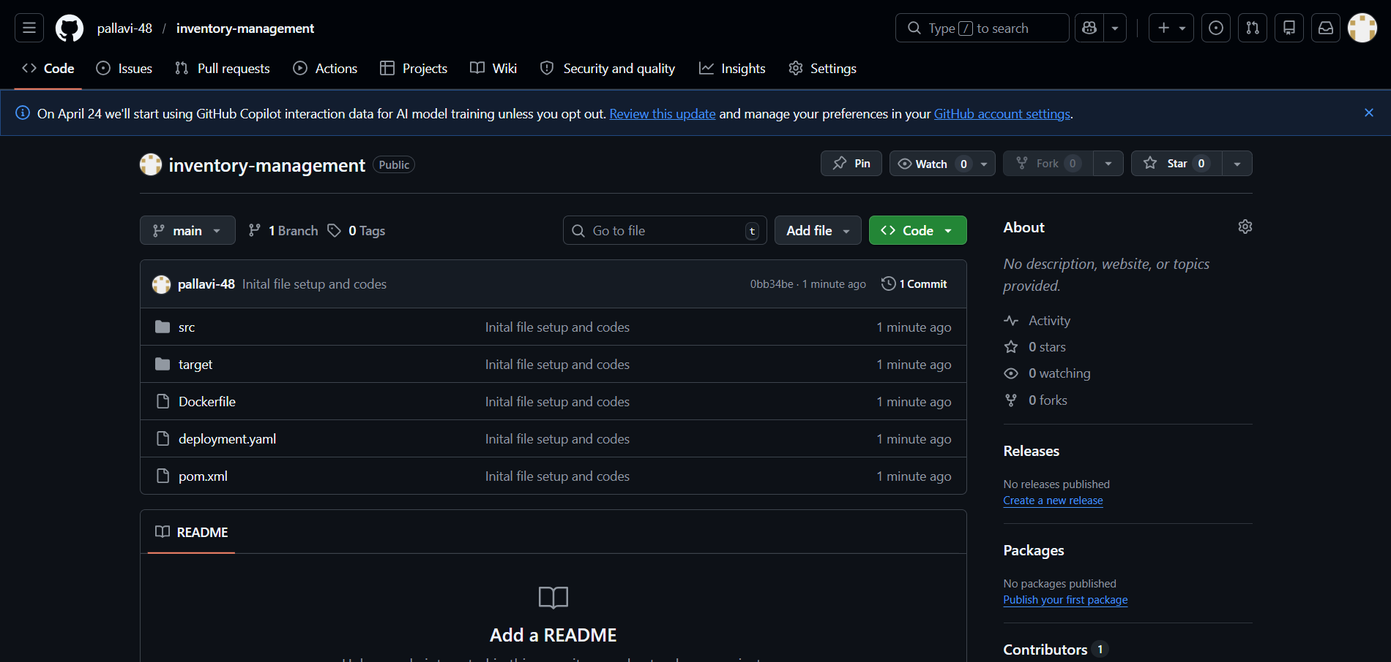
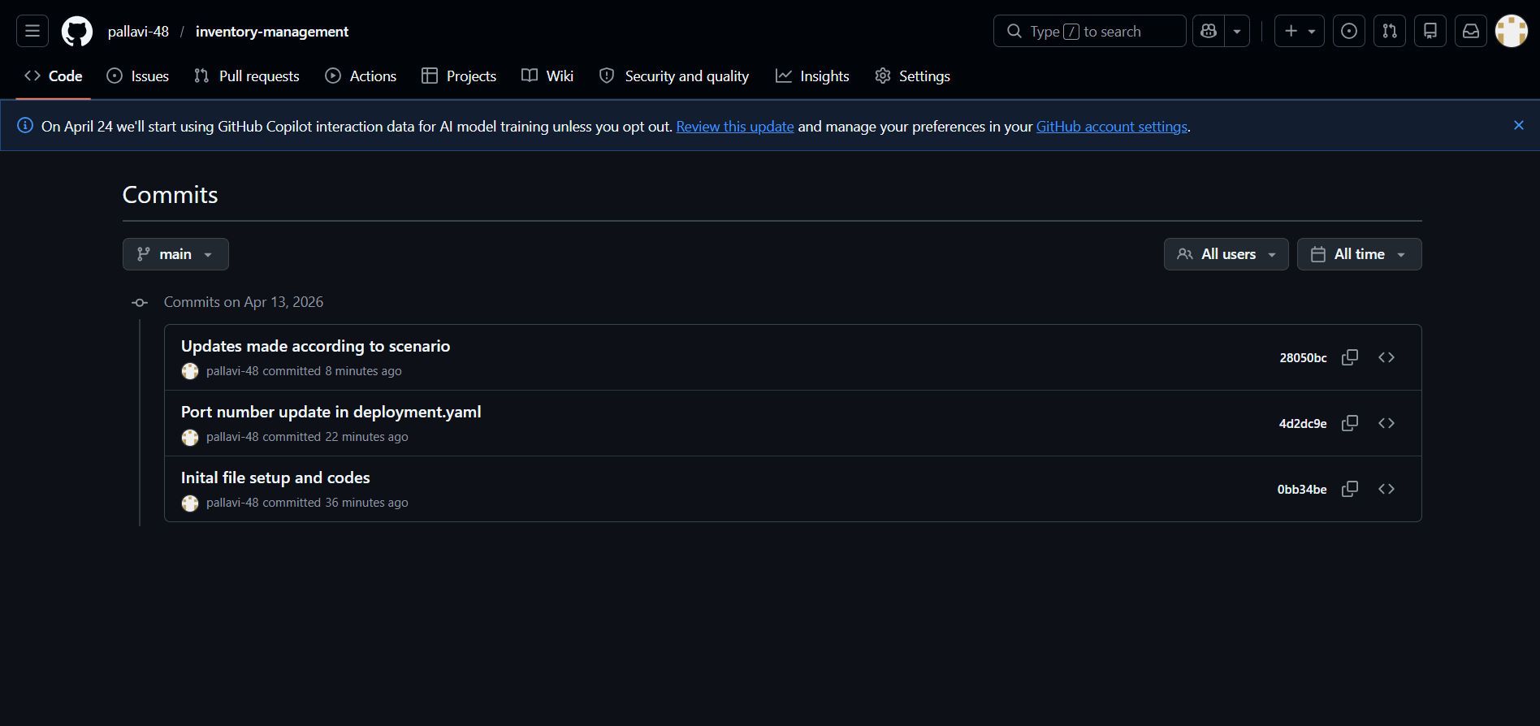
Dockerfile
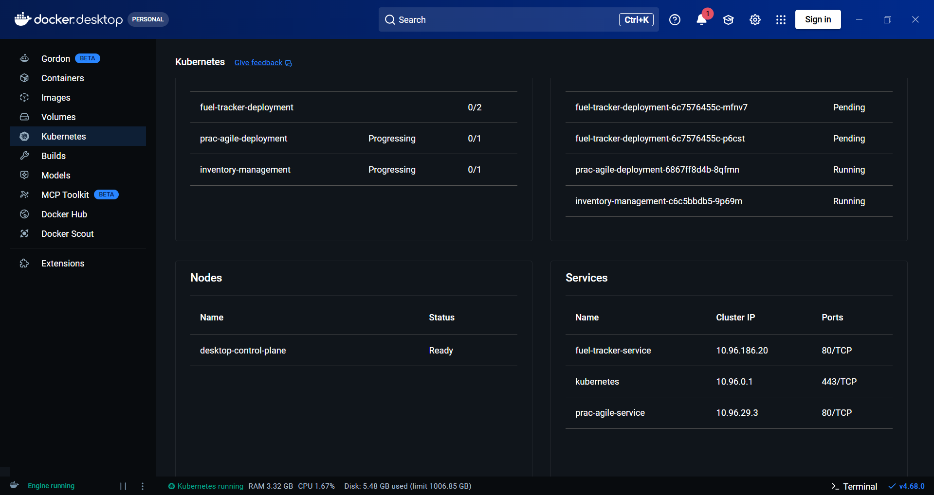
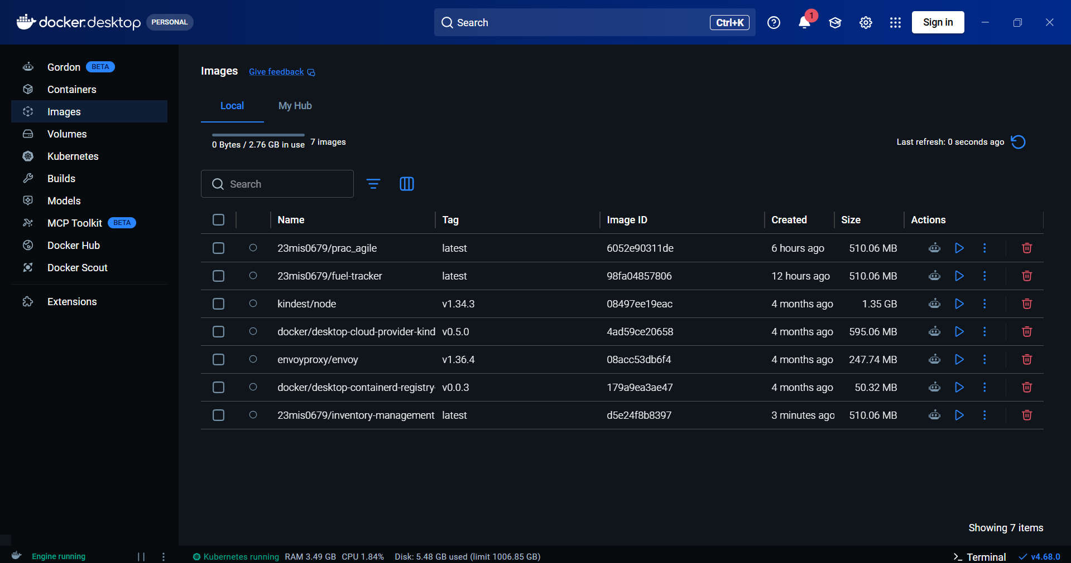
Setup Version control using Github
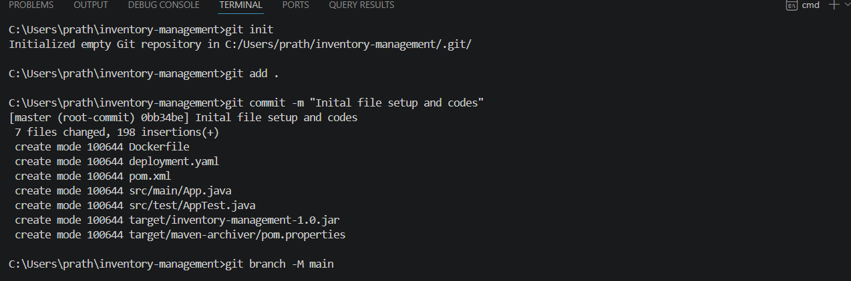
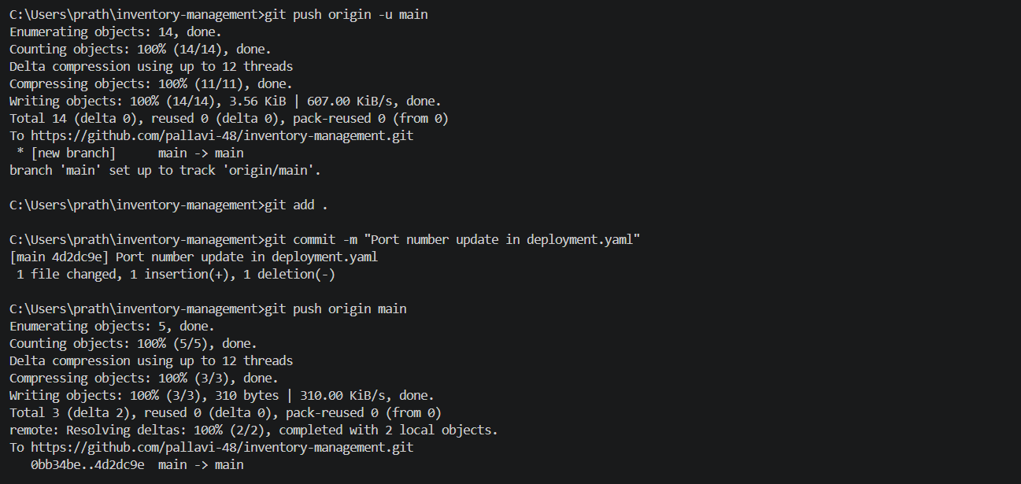
Jenkins CICD pipleline setup
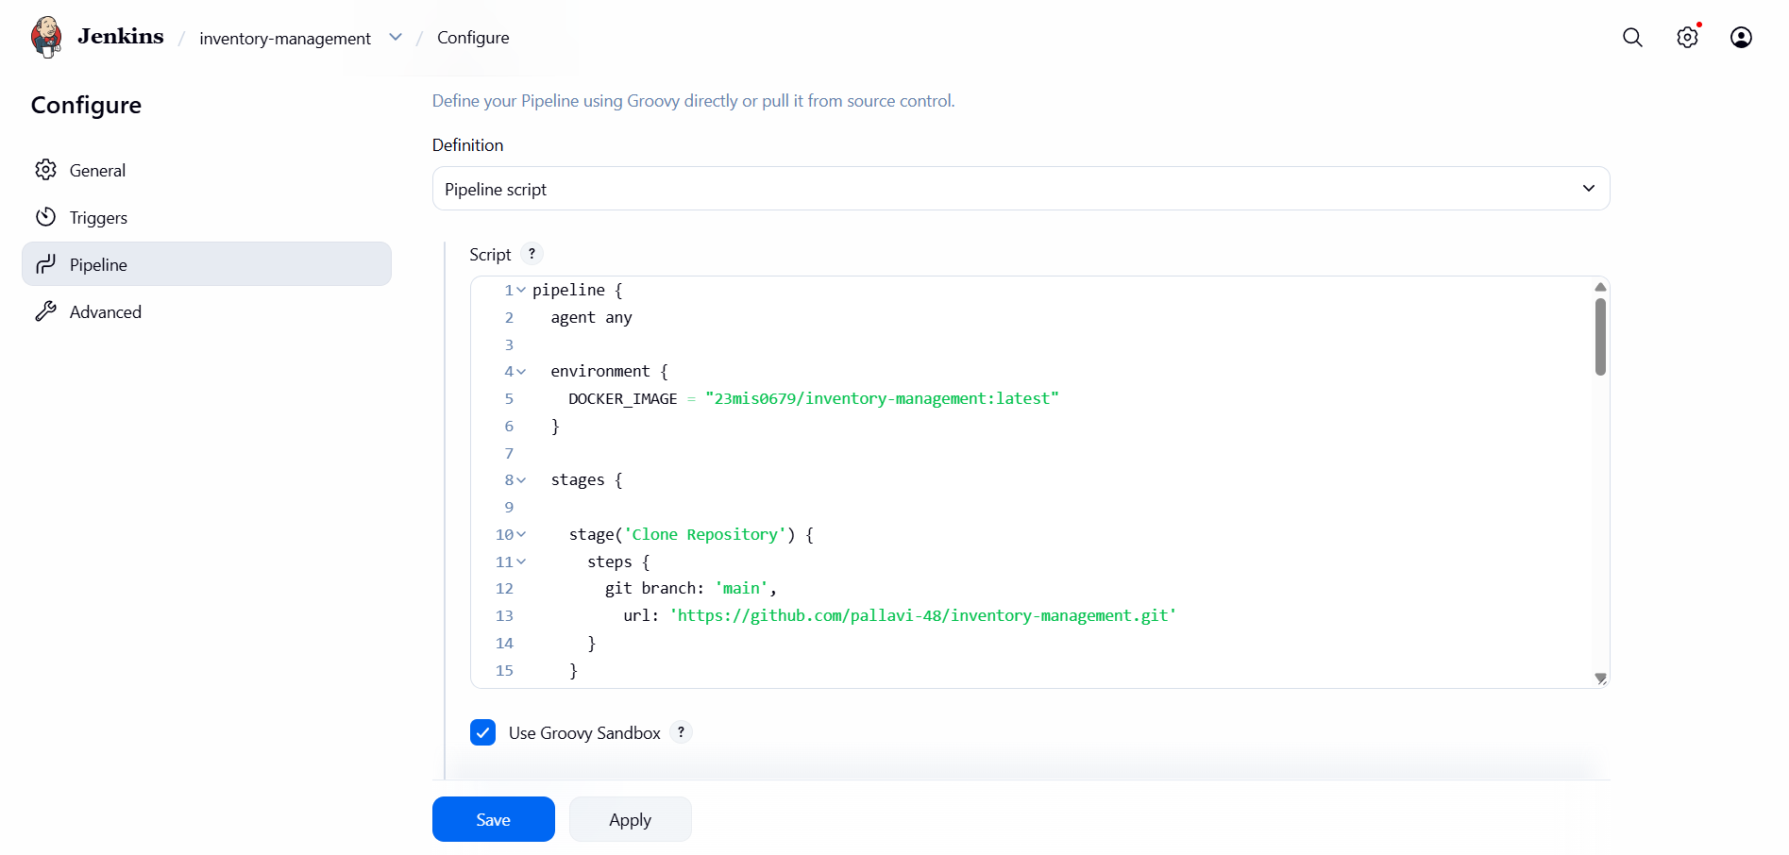
Pipeline code
pipeline {
agent any

environment {
DOCKER_IMAGE = "23mis0679/inventory-management:latest"
}

stages {

stage('Clone Repository') {
steps {
git branch: 'main',
url: 'https://github.com/pallavi-48/inventory-management.git'
}
}

stage('Build and Run Tests') {
steps {
bat 'mvn clean test'
}
post {
always {
junit allowEmptyResults: true, testResults: '**/target/surefire-reports/*.xml'
}
}
}

stage('Package Application') {
steps {
bat 'mvn clean package -DskipTests'
}
}

stage('Build Docker Image') {
steps {
bat "docker build -t %DOCKER_IMAGE% ."
}
}

stage('Push to DockerHub') {
steps {
withCredentials([usernamePassword(
credentialsId: 'dockerhub-creds',
usernameVariable: 'DOCKER_USER',
passwordVariable: 'DOCKER_PASS'
)]) {
bat """
docker login -u %DOCKER_USER% -p %DOCKER_PASS%
docker push %DOCKER_IMAGE%
docker logout
"""
}
}
}

stage('Deploy to Kubernetes') {
steps {
bat 'kubectl apply -f deployment.yaml'
}
}
}

post {
success {
echo 'Pipeline completed successfully!'
}
failure {
echo 'Pipeline failed — check logs '
}
}
}
